James Moran

This document is the Post-Mortem Report of the game put together for CGP605: Mobile Applications.

James Moran, Q12494305, CGP605, AE2

Post-Mortem

Contents

**No table of contents entries found.**

# Project Tracking

For our project, we put together a group-workload sheet, with the delegated tasks for each member of the group and the hours that they were expected to take on each of these tasks (see Fig. 1 of Appendix A: Figures).

I kept my progress on track for the project, by logging my progress in a table, that is editable online. This table is similar in layout to the table that I put together for group-work in Engineering Software Systems, last year (Fig. 2 of Appendix A: Figures).

So, for each phase of the project (putting together the Project Proposal, Prototype, Alpha, Beta and the Finished Game), each group member is expected to complete certain tasks as per the phase of the project (e.g. for the Project Proposal Phase, I was expected to consider the Risks of the project, provide documentation on the tasks I had further down the line and how I would manage the Workload). I was given the project-long responsibility of setting-up a GitHub repository and managing it (resolve conflicts between branches, properly merging branches etc.) A copy of my week-by-week time-log, is available under Fig. 3 of Appendix A: Figures.

Each team member was also allowed to review the meetings of a particular week, as Anthony took the minutes of each meeting, that we could use for continuous reflection throughout the project (a sample of these minutes, is available at Fig. 4 of Appendix A: Figures).

We used Trello, for a team-level overview of which tasks team-members were currently completing, as well as for communicating certain matters on the project, putting up notes going into further detail for certain aspects of the project etc. A sample of the Trello-Boards we part together, can be found under Fig. 5 and 6 of Appendix A: Figures.

Text-messages were also used on occasion (mostly between me and Jack), as a faster means of communication, when a response within a few minutes was paramount.

# Reflection

## Negative Aspects

* Clashes between me and Jack: These were on certain components of the project, such as how collision should be handled, issues relating to coding standards and misunderstanding between me and him, on what issues we were currently facing, or success stories for certain User-Stories (mistaking one for the other)
* Concerning Modularity: As was initially planned for the project, we had intended for there to be multiple levels, with enemies having different attack patterns (causing the Player to have to adopt new movement strategies for dodging Enemy projectiles), as well as different types of enemies (commander, boss, spawner), which would have different stat lines. In reality though, we had not tried to make the project’s implementation in Unity (the game engine we used), modular, which would allow for an iterative pattern to develop new levels and introduce new enemy-types to the Player (as for the one level we had, many of its assets were static for that level, not taking into account different types of enemies and attack patterns for example)

# Improvements

# Appendix A: Figures

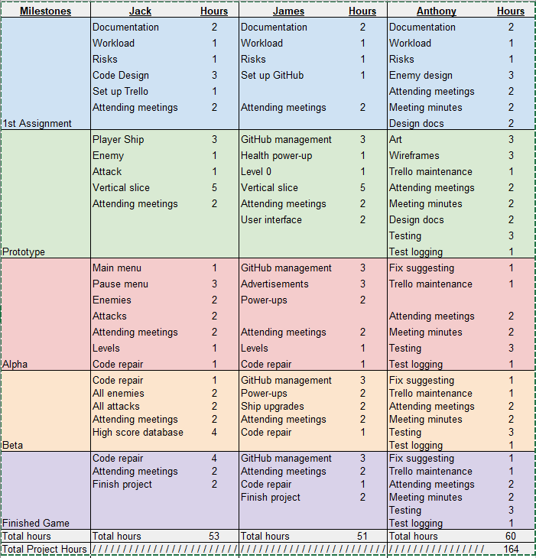Figure 1: The group-workload sheet of each team-member’s delegated tasks, and the predicted hours for each task:

Figure 2: An example of the table that was used for Engineering Software Systems, as a basis for the table I have put together for use in this project:

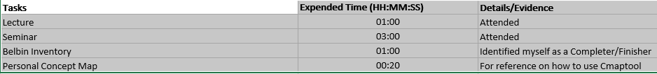

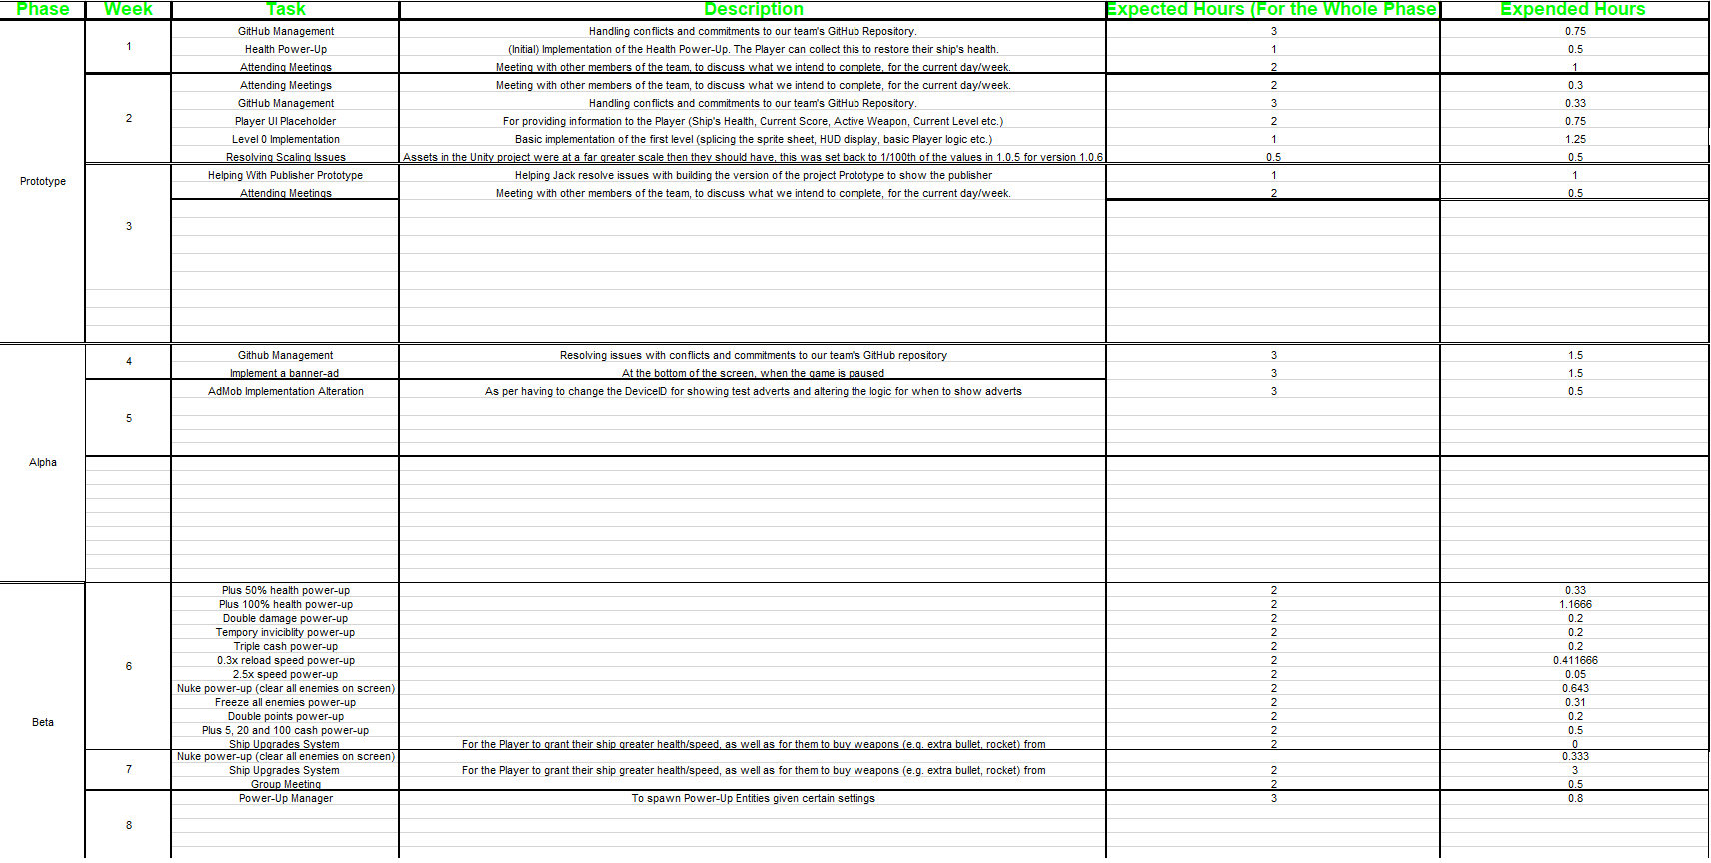Figure 3: A sample of my week-by-week time-log used during the project:

Figure 4: A sample of the minutes for a meeting, put together by Anthony Boys:

This group meeting took place on the 2nd of October 2017, at 5:00 PM.  
People present: Anthony Boys, Jack Evans, James Moran.

People absent: none.

In this meeting, we first of all set up a GitHub and Trello board for the project.  
Finally, we discussed an idea for the project. We all agreed that the design will be a simple game, with the genre of either “bullet hell” or “space invaders”; that the game may have controls that are alternative to using an accelerometer or gyroscope; that there may be a system of player progression; that there will be differing enemies, including boss enemies; that difficulty will increase over levels; and that there may be power-ups, health pickups, drops and end-of-level bonuses. (Anthony Boys, 2017)

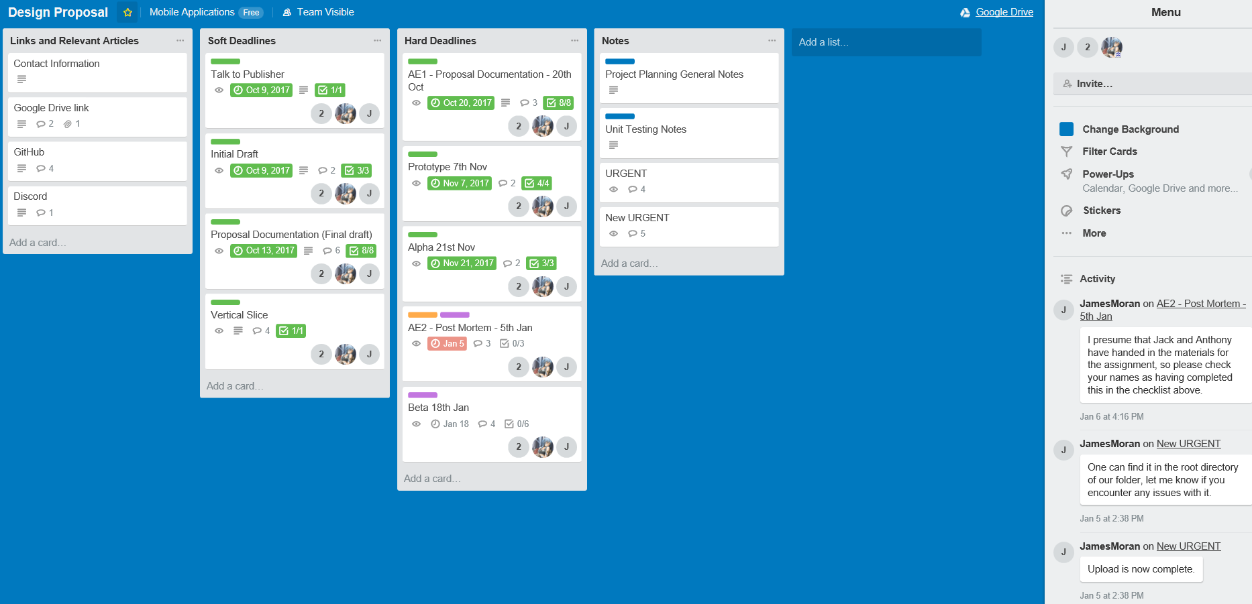Figure 5: Our ‘Design Proposal’ Trello-Board (the primary board that we used throughout the duration of the project):

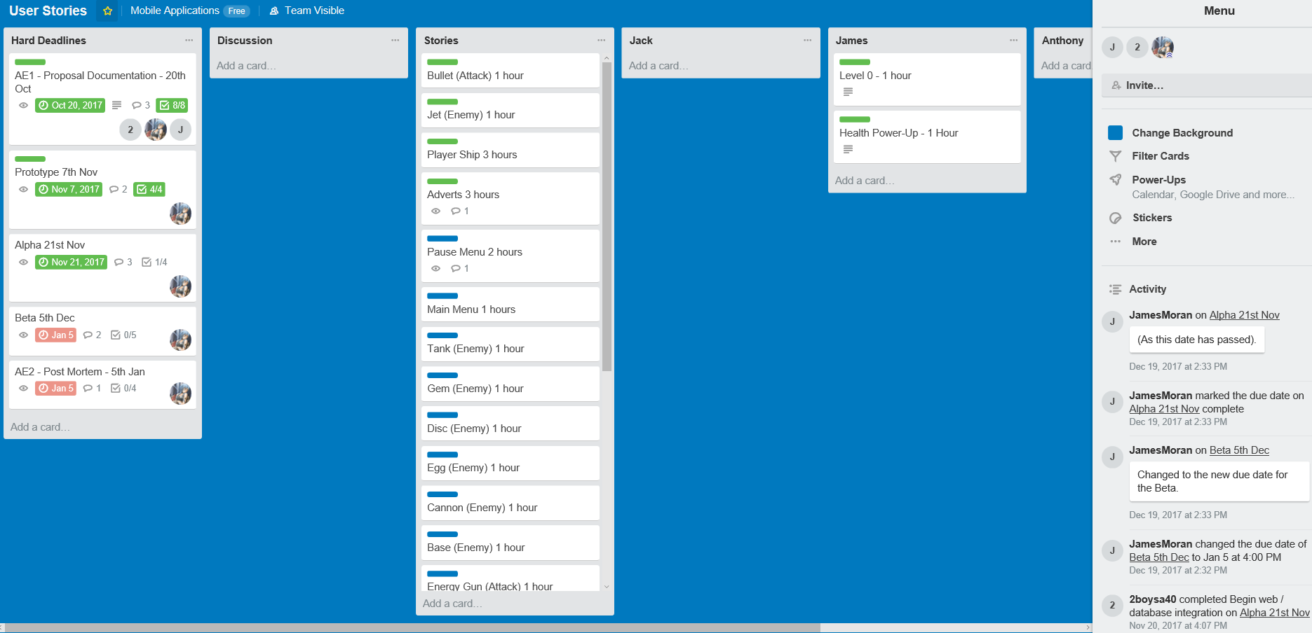Figure 6: Our ‘User Stories’ Trello-Board (a secondary board used for tracking progress on the implementation of specific user-stories for the project):

# References

1. Anthony Boys, 2017. *Copy of Meeting Minutes* [Viewed on the 10/01/2018]. Available from: <https://drive.google.com/open?id=1zxLlAtjeqHG9ca_-QfohmyLYrLHpk49oHcUAeVVD6rI>